Country Meadows of Bethlehem Nursing Center
4025 Green Pond Road
Bethlehem, PA 18020
Facility Contact: Executive Director
(610) 882-4110, ext. 25502
Facility Plan

Core Principles of COVID-19 Infection Prevention

- Visitors who have a positive viral test for COVID-19, symptoms of COVID-19, or currently meet the criteria for quarantine, should not enter the facility until they meet the criteria used for residents to discontinue transmission-based precautions (quarantine). Facilities should screen all who enter for these visitation exclusions.
- Hand hygiene (use of alcohol-based hand rub is preferred)
- Face covering or mask (covering mouth and nose) and physical distancing at least six feet between people, in accordance with CDC guidance
- Instructional signage throughout the facility and proper visitor education on COVID- 19 signs and symptoms, infection control precautions, other applicable facility practices (e.g., use of face covering or mask, specified entries, exits and routes to designated areas, hand hygiene)
- Cleaning and disinfecting high-frequency touched surfaces in the facility often, and designated visitation areas after each visit
- Appropriate staff use of Personal Protective Equipment (PPE)
- Effective cohorting of residents (e.g., separate areas dedicated to COVID-19 care)
- Resident and staff testing conducted as required at 42 CFR § 483.80(h) (see QSO-20- 38-NH)
Testing Plan

- Test Availability and Lab Relationship
  - We have worked with various labs to procure adequate testing kits and prompt turnaround time to inform our strategy for cohorting and infection control. Currently we have several contracts, but our main relationships are with Genetworx and HNL.
  - We are able to obtain several hundred test kits in less than 24 hours should we have one symptomatic resident or an outbreak. We are able to test both asymptomatic and symptomatic staff alike. Our medical supply vendor is able to fulfill orders for additional testing supplies upon request. We have nurses on staff already trained to administer these tests.
  - We have access to a text-messaging system to alert all staff that they need to be tested timely, and have an email system to alert POAs that we are testing our residents.
  - We have adequate testing supplies to be able to test vendors, volunteers, and non-essential staff.
  - Point of Care testing can be performed by trained facility staff via a BD Veritor instrument or BinaxNOW Abbott cards, with results obtained in as little as 15 minutes.

- Co-worker Testing
  - We retain the right to have all co-workers complete COVID-19 testing, and will require that we are provided with the results of that test which will be maintained confidentially in the co-worker’s medical file. Regardless of vaccination status, our community has the capacity to and will test:
    - All employed co-workers for a baseline Universal test by July 24, 2020, per the Order of the Secretary of the Pennsylvania Department of Health;
    - Symptomatic co-workers or applicants, regardless of vaccination status;
    - Non-symptomatic co-workers or applicants who are believed to be exposed either from work or from other sources who meet the criteria due to vaccination status according to CDC, CMS and DOH guidelines;
    - Non- symptomatic co-workers or applicants in a facility which has an outbreak;
    - Non- symptomatic co-workers or applicants in a facility based on recommendations from DOH, CDC or our Medical Director;
    - New facility onset of COVID-19 cases;
    - As a result of a higher-risk exposure, regardless of vaccination status. The co-worker will be tested immediately and 5-7 days after exposure.
    - Routine testing at a frequency prescribed in the table above, based on the county positivity and/or transmission rate reported in the past week. Co-workers who are up-to-date on recommended vaccinations with no COVID-19 like symptoms and no known exposure will be exempted from routine testing.
    - Refusal to be tested – see section on Screening Protocol, 2-c

DEFINITIONS
“Close contact ” refers to someone who has been within 6 feet of a COVID-19 positive person for a cumulative total of 15 minutes or more over a 24-hour period.

“Level of community transmission” refers to facility’s county level of COVID-19 transmission. This metric uses two indicators for categorization (1. Total number of new cases per 100,000 persons within the last 7 days and 2. Percentage of positive diagnostic and screening nucleic acid amplification tests (NAAT) during the last 7 days), which can be found on the Centers for Disease Control and Prevention (CDC) COVID-19 Integrated County View site at https://covid.cdc.gov/covid-data-tracker/#county-view.

“Up-to-date” means a person has received all recommended COVID-19 vaccines, including any
booster dose(s) when eligible.
“Higher-risk exposure” refers to exposure of an individual’s eyes, nose, or mouth to material potentially containing SARS-CoV-2, particularly if present in the room for an aerosol-generating procedure. This can occur when staff do not wear adequate personal protective equipment during care or interaction with an individual. For more information, see CDC’s "Interim Guidance for Managing Healthcare Personnel with SARS-CoV-2 Infection or Exposure to SARS- CoV-2."

Routine Testing Intervals by County COVID-19 Level of Community Transmission
Level of COVID-19 Community  Transmission | Minimum Testing Frequency of Staff who are not up-to-date+
Low (blue) | Not recommended
Moderate (yellow) | Once a week*
Substantial (orange) | Twice a week*
High (red) | Twice a week*

- Resident Testing
    - All residents were offered a COVID-19 test for a baseline Universal test by July 24, 2020, per the Order of the Secretary of the Pennsylvania Department of Health;
    - Symptomatic residents, who will be tested within 24 hours of identification of symptoms;
    - Non-symptomatic residents who are believed to be exposed to a COVID positive co-worker or resident sources who meet the criteria due to vaccination status according to CDC, CMS and DOH guidelines;
    - Non- symptomatic residents in a facility which has an outbreak;
    - Non- symptomatic residents in a facility based on recommendations from DOH, CDC or our Medical Director;
    - New facility onset of COVID-19 cases;
    - As a result of a higher-risk exposure regardless of vaccination status. The resident will be tested immediately and 5-7 days after exposure.
    - Refusal to be tested – Residents who refuse to be tested will be placed on Transmission Based Precautions in the YELLOW Zone for 14 days and monitored for signs and symptoms of COVID-19.
- Outbreak Testing
    - When a new case of COVID-19 among residents or staff is identified, the facility will immediately begin outbreak testing on those who have been identified, through contact tracing, to have had a higher-risk exposure.
      - In all cases, visitors will be notified about the potential for COVID-19 exposure in the facility (e.g., appropriate signage regarding current outbreaks), and adhere to the core principles of COVID-19 infection prevention, including effective hand hygiene and use of face-coverings.
Testing Trigger | Staff | Residents
Symptomatic individual identified | Staff, regardless of vaccination status, with signs or symptoms must be tested. | Residents regardless of vaccination status, with signs or symptoms must be tested.
Newly identified COVID- 19 positive staff or resident in a facility that can identify close contacts | Test all staff, regardless of vaccination status, that had a higher-risk exposure with a COVID-19 positive individual. | Test all residents, regardless of vaccination status, that had close contact with a COVID-19 positive individual.
Newly identified COVID- 19 positive staff or resident in a facility that is unable to identify close contacts | Test all staff, regardless of vaccination status, facility-wide or at a group level if staff are assigned to a specific location where the new case occurred (e.g., unit, floor, or other specific area(s) of the facility). | Test all residents, regardless of vaccination status, facility-wide or at a group level (e.g., unit, floor, or other specific area(s) of the facility).
Routine testing | According to Community Transmission | Not generally recommended

Cohorting Plan

When COVID + residents are identified, cohorting positive residents is important to prevent spread of the disease to nearby residents and other parts of the building. Residents will be cohorted in separate areas based on zones.

GREEN Zone

- Have had no exposure or fully vaccinated individuals AND are asymptomatic.
- Monitor temperature, pulse and pulse oximetry daily. If a positive case is identified amongst a resident or co-worker, monitoring will increase to every shift until testing reveals no additional positive cases for a minimum of 14 days.
- All residents will dine in their rooms or in the dining room, based on preference.

YELLOW Zone

- Residents who:
  - Are isolated due to an exposure to a COVID 19-positive individual. An exposed resident may have tested negative or is not tested AND is asymptomatic.
  - Have COVID 19-like symptoms but have not been tested or refuse testing.
  - Newly admitted and residents who have left the facility for > 24 hours and are not up-to date with vaccine doses.
- Monitor temperature, pulse and pulse oximetry daily. If a positive case is identified amongst a resident or co-worker, monitoring will increase to every shift until testing reveals no additional positive cases for a minimum of 14 days.
- All residents will dine in their room. Residents who require supervised dining may be brought to a common area to dine at least 6 feet from other residents.

RED Zone

- Residents who have tested positive for COVID-19
- Resident will remain in this area for a minimum of 10 days (from the positive test date or the date symptoms started, if not tested immediately) including an improvement in respiratory symptoms and 24 hours afebrile.
- Care Coordination
  - Offer support of Hospice or therapeutic services for all COVID positive residents.
  - Provide additional nursing care, assessment, assistance with medical management.
  - Coordinate needed medical equipment.
  - Communicate with family and coordinate provider visits and family visits (end of life).
  - Monitor vital signs each shift, avoiding night hours to avoid disturbing residents’ sleep.
  - Consider transfer to a Hospital, if needed.
- Provide for resident isolation, loneliness, and decrease in physical activity.
- Staffing Protocol
  - Attempt to follow Department of Health Direction for staffing, as per PA - HAN 509.
“Staff should be designated by Zone as much as possible to minimize risk to exposed (Yellow) and non-exposed (Green) residents. If necessary, using staff in more than one Zone should be prioritized as in the below diagram, which outlines how staff should be assigned. The best option is listed first, and the least desirable option last.”
  - Isolate RED Zone coworkers to the RED Zone area. Staff who are assigned to RED resident Zones ideally should not cross to YELLOW or GREEN zones.
  - If positive and negative residents are located in the same hallway, create two coworker teams, if possible, based on staffing patterns – a RED Team and a Yellow Team.
  - One should be assigned to care for positive residents and the other for negative residents. Coworkers ideally should not cross between positive and negative residents once established.
  - Consideration of staff with high-risk conditions.

- Establish process for support of the COVID unit.
  - Providing cleaning supplies and food.
  - Removing trash and soiled linen.
  - Laundering/drying isolation ponchos or gowns.
  - Provide IVC light for disinfecting masks and other equipment.
  - Provide additional iPads for face-to-face family calls and tele-health visits.
  - Provide equipment for COVID positive residents separate from COVID negative residents.
  - Provide for coworker morale and meals.

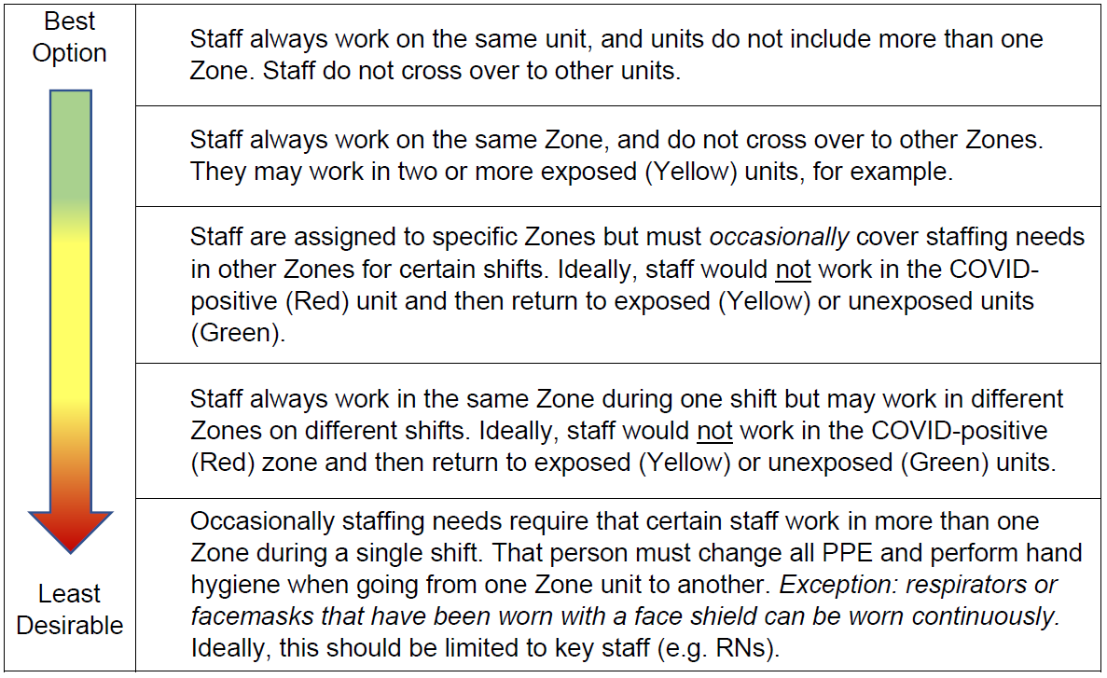

PPE/ Supplies
Adequate supplies for the community will be kept on site, with additional supplies available within 24 hours from a centrally located warehouse. Currently, we maintain at least two months’ supply of N95 masks and KN95 surgical masks as well as re-usable, launderable gowns, eye protection and disposable gloves, and will continue to replenish our supply.

- Refer to Isolation vs. Standard Precautions guidelines.
- N95 respirators will be worn by all co-workers for care of residents with suspected or confirmed COVID-19 infection.
- If regular isolation gowns are not available, launderable gowns will be used. Coworkers may wear the same gown from room to room in completely RED Zones. Change gown for breaks and don a fresh gown. Do not re-don a used/soiled gown.
  - In areas where positive and negative residents are mixed, to prevent spread, coworkers caring for positive residents will not wear their gowns in the hallways and will change gowns in between residents.
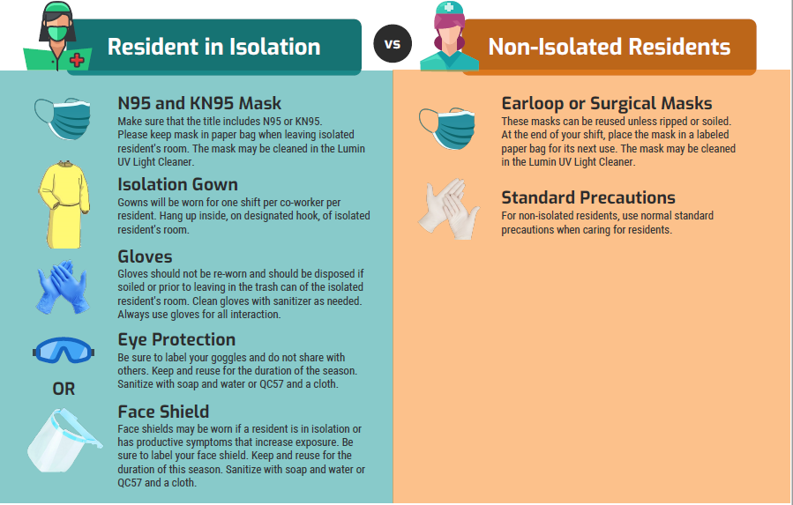

Staffing Plan

- Permanent staff- the facility currently maintains full or part time employees in 90% of our positions. We have a robust PRN (as needed) team, and have relationships with several professional staffing agencies should we go into contingency staffing.
- Additionally, we have several other facilities within less than an hour’s drive and have co-workers willing to travel to and support this facility should the need arise.

Crisis Capacity Staffing Strategy

Under crisis capacity strategies, HCP who have recovered from COVID-19, and are well enough to work, are permitted to return to work before meeting above criteria. Such HCP should be restricted from contact with severely immunocompromised patients (e.g., transplant, hematology-oncology) and facilities should consider prioritizing their duties in the following order:

- If not already done, allow HCP with suspected or confirmed COVID-19 to perform job duties where they do not interact with others (e.g., patients or other HCP), such as in telemedicine services.

- Allow HCP with confirmed COVID-19 to provide direct care only for patients with confirmed COVID-19, preferably in a cohort setting.

- Allow HCP with confirmed COVID-19 to provide direct care for patients with suspected COVID-19.

Screening Protocol

- Residents— Vital sign checks will be performed at least once per day which includes 02 saturation, pulse and temperature. Frequency will change to once per shift in response to facility outbreak procedures.
- Staff and Essential Healthcare Personnel-- Co-workers are considered essential. Any agency or other vendor providing essential care would also be considered essential. As such anyone in these categories must:
  - Honestly and fully complete a daily screening questionnaire (see exhibit 1), which includes symptoms monitoring, travel, other work experiences and possible exposure before beginning work.
    - Each location will have different screening areas, which may change over time due to the need to cohort co-workers during outbreaks.
    - Each location will provide appropriate supplies with safety and social distancing incorporated.
  - Submit to a temperature scan before beginning work and prior to departure.
    - Each location may have different methods for scanning temperatures and will provide all appropriate supplies.
    - A threshold temperature of 100 degrees will be used, based on CDC, DOH and our Medical Director’s recommendations. If a co-worker’s temperature is confirmed to be 100 or higher, he or she should not enter their work area, should immediately remove themselves from any contact with others, and contact their supervisor.
    - Each co-worker may request and receive a retest of their temperature if they are concerned about accuracy of the test.
    - Co-workers who fail the temperature screen will be contacted by home office or campus clinical team and offered a COVID-19 test.
    - Per CDC and DOH guidelines, we will follow the symptom-based return to work strategy in combination with a 10-day quarantine.
  - Refusal to submit to completing the screening questionnaire, temperature screen and/or COVID-19 testing will be grounds for refusal to hire applicants, and for termination of employment of existing co-workers. A “refusal to test” is defined as any conduct that would obstruct the proper administration of a test.

- Visitors, Volunteers, and non-essential personnel
  - The screening tool used for will be used for Visitors, Volunteers, and non-essential personnel EXIBIT 2.
  - Anyone failing to comply with this screening or who fails the screening will be asked not to enter the facility.
- Compassionate Caregivers
  - The screening tool used for will be used for Visitors, Volunteers, and non-essential personnel EXIBIT 2.

Communal Dining

- Schedule
    - Residents not on isolation will be given the option to return to the dining room at a capacity that allows for social distancing. If necessary, roommates and/or fully vaccinated residents will be seated at the same table.
    - The community will continue to serve residents in their rooms if they wish to remain.
    - Residents identified as requiring hands on assistance with feeding will be serviced according to their individual needs listed in their Care Plan.

- Physical Set up
  - The tables will be staggered and located at least 6 feet apart. Residents will be escorted to assigned seats which will allow 6 ft. distance. Where this is not possible, roommate residents may be seated together. Dining rooms will be expanded into nearby living areas to further separate residents while dining.
- Infection Control and Staff PPE
  - The co-workers serving meals will wear masks, eye wear and gowns. The area will be cleaned in between seatings with products appropriate for disinfecting and effective against COVID-19.

- Other Aspects
  - Residents will be asked (if able) to wear their mask to their table and leave it on the table, then use hand sanitizer to perform hand hygiene.

Activities

Activities will be offered to residents based on ability to maintain appropriate social distancing, understand masking, maintain hand hygiene and infection control practices. Residents exposed to or with confirmed COVID-19 will not be engaged in any group activities. Communal activities may be introduced by levels to mitigate the risk of additional spread if a case of COVID-19 is identified within the facility.

- Level 1- Limited activities will be offered, with an emphasis on serving those residents most at risk for isolation. Residents will be offered programming on our custom TV channel, through ‘hallway’ entertainment while sitting in their doorway in layouts where this allows social distancing (i.e. seated exercise, hallway happy hour) or via packets of entertainment brought to their room or one on one socially distanced visits. Residents unable to socialize without supervision will be brought into small group activities of no more than 5 residents. This may include fitness classes, art, educational lecture, or other activities that allow residents to remain masked and distanced. Efforts will be made to prioritize activities being outdoors when the weather is not inclement and adequate shade may be provided.
- Level 2- As in level 1, opportunities for in-room, hallway, and outdoor small group activities remain. Residents able to comply with mask wearing, social distancing, and hand hygiene may participate in larger activities of up to ten residents (i.e. BINGO, movies, and meditation).
- Level 3- Similar to levels 1 and 2, residents have several options for social-emotional wellbeing, but also may engage in larger group activities, such as viewing a performer. Resident attendance to large group activities is contingent on their unexposed status and ability to comply with infection control protocol.

Outings

- Non-Medical outings are allowed for residents not under isolation due to COVID-19. They will be permitted while adhering to DOH and facility guidelines.
  - Residents who are not up-to-date on vaccine doses may be placed in quarantine upon return to the facility.

Non-Essential Personnel

- Non-essential Personnel will be allowed as deemed necessary. All Non-essential Personnel will be required to undergo the Visitor Screening, will need to comply with social distancing, hand hygiene, and masking expectations, and will be asked to ensure in writing that they have not been serving COVID positive individuals.
- Barbers and Beauticians will be allowed on site, with the expectation that they will wear an assigned KN95 or N95 mask, they will sanitize between residents with the appropriate disinfectant, they will use only one cape per resident, they will perform only necessary services, and they will submit to testing as requested by the facility, including the option to test prior to return to the facility.
Visitation

- Outdoor visitation is preferred when the resident and/or visitor are not up-to date with all recommended COVID-19 vaccine doses.
- Visitation will be limited to two adult visitors and a maximum of one child visitor under the age of 12. Adult visitors must be able to manage any child in accompaniment and any child over the age of two must be able to wear a cloth mask or face shield. All visitors (over 2) must wear masks and maintain social distancing. Facemasks will be provided by the facility if the visitor(s) or resident cannot provide their own.
- All visitors must sign the Country Meadows Nursing Center Mask Contract EXHIBIT 3, acknowledging their understanding of the facility’s visitation guidelines and masking requirements, prior to visiting.
- In areas of low to moderate transmission, the safest practice is for residents and visitors to
wear face coverings or masks and physically distance, particularly if either of them is at
increased risk for severe disease or are not up-to-date with all recommended COVID-19
vaccine doses.
- Residents, regardless of vaccination status, can choose not to wear face coverings or masks
when other residents are not present and have close contact (including touch) with their
visitor.
  - Residents (or their representative) and their visitors, who are not up-to-date with all
recommended COVID-19 vaccine doses, should be advised of the risks of physical
contact prior to the visit.
- All visitors must sign in prior to their visit, including sharing their name and contact information, and will be screened for risk factors per screening tool in EXHIBIT 2. Any visitor who does not pass the screening will not be allowed to visit. Visitors must sign out upon departure.
- An outdoor visitation area will provide coverage from inclement weather, or if not feasible, an indoor visitation area will be provided.
- Any indoor visitation area will be located as closely as possible to an outdoor entrance and will avoid any route that would cross through a resident area, and more specifically a COVID-positive unit.

ATTACHED:
- EXHIBIT 1, Screening Tool for Employees
- EXHIBIT 2, Screening Tool for Resident Visitors, Non-essential Healthcare Workers
- EXHIBIT 3, Country Meadows Nursing Center Mask Contract
EXHIBIT 1
EXHIBIT 2
EXHIBIT 3
